**AWS Task-2**

Set up a VPC with an Internet gateway, create a public subnet with 256 IP addresses, a private subnet with 256 IP addresses, make a route table connecting the Internet gateway and the subnets, and launch a Linux EC2 instance by using the above VPC and public subnet.

* **Set up a VPC**

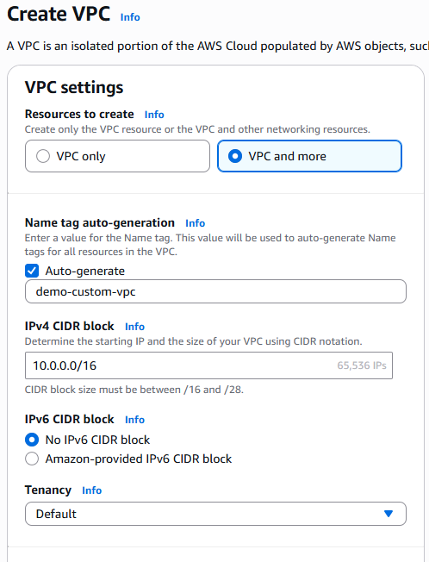

* **create a public subnet with 256 IP addresses, a private subnet with 256 IP addresses**

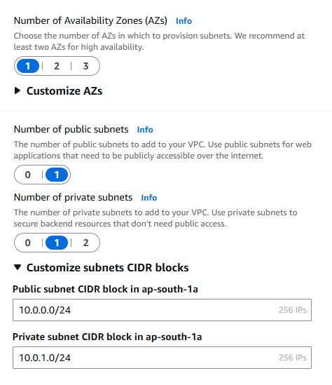

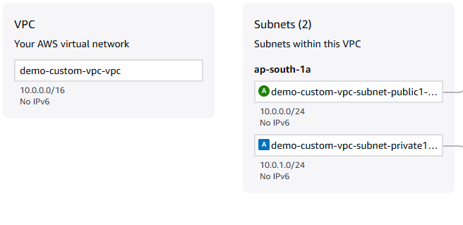

**Make a route table connecting the Internet gateway**

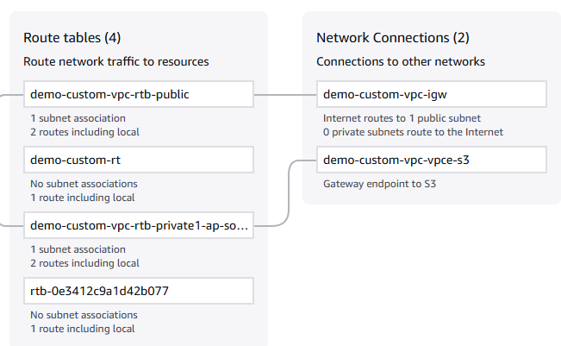

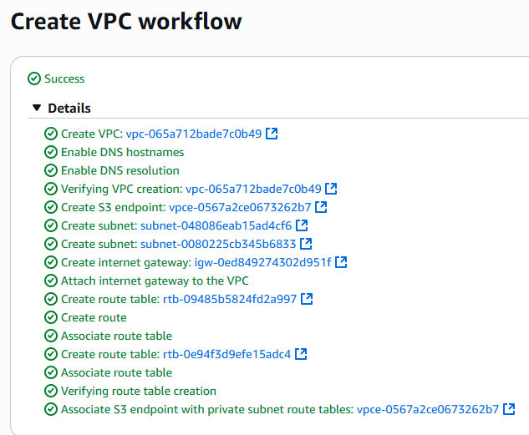

**Creation of EC2 Instance**

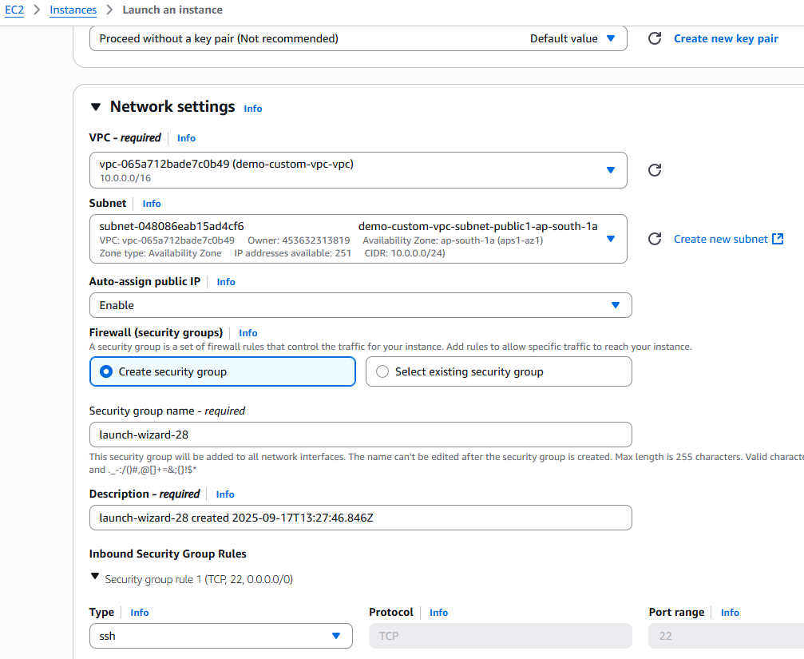

**Launch a Linux EC2 instance by using the above VPC and public subnet.**

